Prerequisites
The following prerequires are needed:
- Installation of Microsoft Excel
- Installation of VISBO Project Edit
Installation of visbo-connect
Download the file “visbo-connect Setup 0.8.1.exe”
Execute the exe file
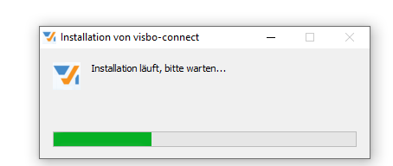
Wait the for the installation window to disappear. The program should be installed.
Check in Programs shows:
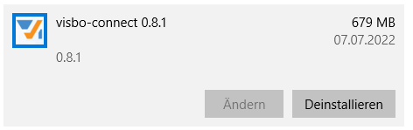
Download the file vcn_config.json and put it into the folder
C:\Users\<username>\AppData\Roaming\visbo-connect
Edit the file and adjust the paths for the two configuration parameters
{"excelExe":"C:\\Program Files (x86)\\Microsoft Office\\root\\Office16\\EXCEL.EXE",
"speSheet":"C:\\Visbo\\VISBO SPE\\Visbo Project Edit.xlsx"}
Configuration of the Project Edit Button
For the successful usage VISBO Connect and VISBO Project Edit you need to configure an additional button in Web User Interface. This is done a special setting in your VISBO Center.
Create json file with the following content: {"parameter":["vpid","vpvid"]} and save it to the local storage.
Go to the VISBO Center Administration page and select settings.
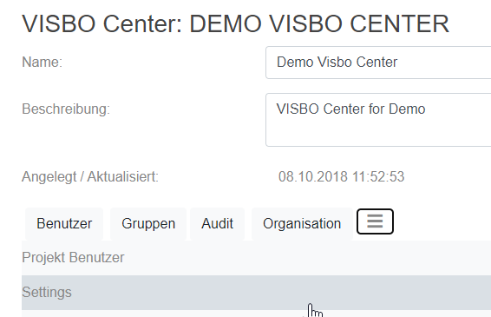
Click on the “Add Setting”-Button and select the file created json file. Afterwards click on Import.
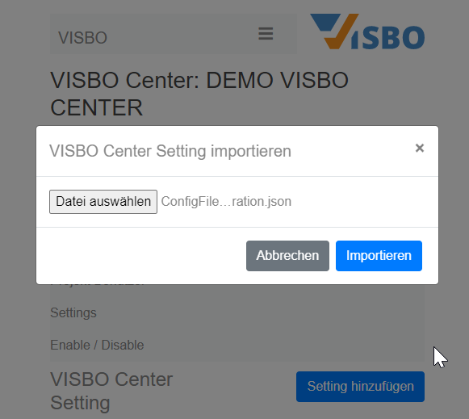
Use “CustomEdit” as type and choose the name of the button.
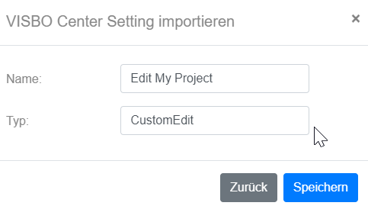
Now the new Button will show up for each project in the VISBO Center
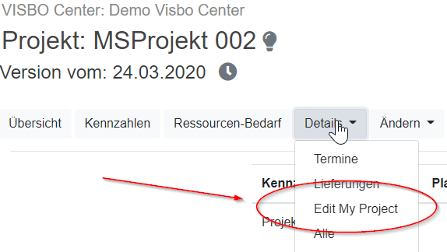

Usage Project Edit started from the Web UI
Now whenever you click on the newly defined Project Edit Button in WebUI the following window shows up:
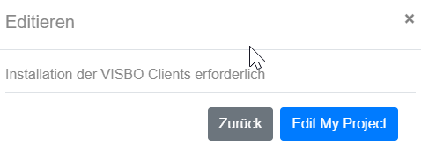
After you click on “Edit my Project” the VISBO Project Edit will start up in Excel and the project values can be changed in within the VISBO Project Edit.
